**EE402 Assignment 2 – 2019-2020**

**Final Report Java**

**Name: LARBODIERE Matthis**

**ID Number: 19101694**

**Programme: ESCAOO**

1. How to run the code

I will explain in part 2 why everyone doesn’t work very well but here are the steps to follow to run my code :

* You have to run the GUI.java file to open the Graphic User Interface. If it doesn’t exist yet, you have to right click on the GUI class and click then on “Coverage As”. Then “Coverage Configurations”. Now you type “GUI” in the name space and click on Apply. Choose my project “Assignment3_LARBODIERE” and then type ee402.GUI as main class. Click on “Coverage”. Then, as you’ve finished, click on “Run As” and “GUI” for the Java Application.
* After that, you have to go in the command prompt and write : cd and the address of my bin’s code. On my computer it’s cd C:\Users\matla\Desktop\Assignment3_LARBODIERE\bin
* Then make sure you’ve installed the last version of java (because I’ve wasted a lot of time on this) and write : java ee402.Client localhost firstC
* Go back to the Graphic User Interface to see the curve of the first client

1. The problem on the Raspberry Pi

I tried so much to understand why the connection between Putty (the application that I’ve used to make the connection between the Raspberry and my code) and the main in the Client class doesn’t work. The problem is because Putty seems to understand that there isn’t a main menu in the class Client. However, you will see in my code that there is a main menu in the class Client because I’ve moved it from the ThreadedServer class to the Client class. It even not connect to the server.

The error I have is “Could not find or load main class Assignment3_LARBODIERE.Client “.

I couldn’t run my code on an other computer also. So I’ve made the assignment with the command prompt only.

Here is the screenshot of my error :

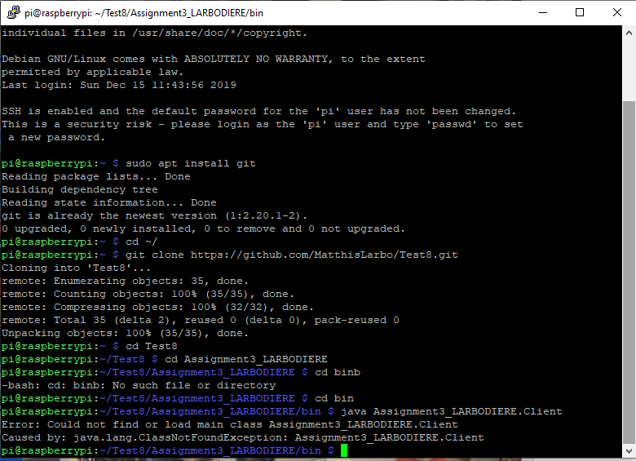

However, my Putty is correctly build because I can load the computer temperature :

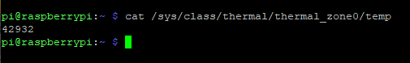

1. The Command Prompt

As I said in part 1, I can make a connection between the command prompt server and the client. However, because I couldn’t get the values of the temperature, I have no choice that to choose random values for the temperature. The temperature I’ve choose don’t’ exceed 50 °C and don’t’ go below 0 °C.

Here is the virgin graph with no values :

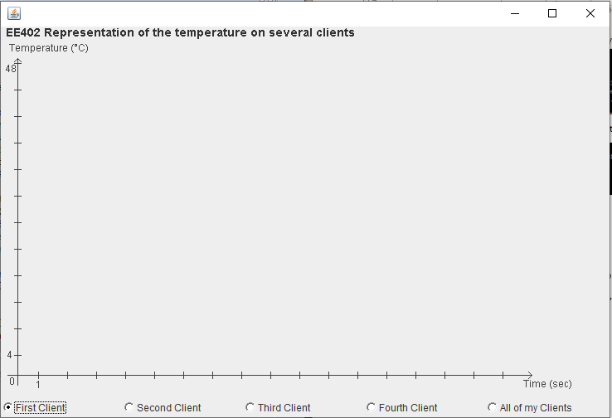

I’ve made an orthogonal set with the seconds for the abscissa axe and the temperature in the ordinate axe. I’ve also made Check buttons boxes where you can choose which client you want to display. You have to run all the clients in the command prompt to see several curves.

Now let’s run the command prompt. I’ve selected 25 random values for the temperature and a frequency of 1 sec for each client.

If we want to run different clients, we had to run the first client, then wait 30 seconds as the values of the temperature appears on the graph, and then run the second client etc. Indeed, I can run different clients on my graph.

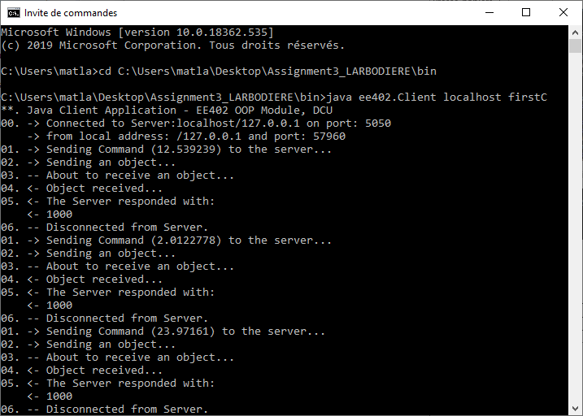

We can see that the client send the value of the random temperature to the server, send then an object. The object is received by the server and display the value on the GUI. Then waits 1 sec do the same thing 25 times.

On the Eclipse console, we can see (here run for the second client secondC) :

